

Data Technician

Name: Rocio Corcoles Vallejo
Course Date: 17/11/2025
Table of contents
Day 1: Task 1 3
Day 1: Task 2 5
Day 3: Task 1 9
Day 4: Task 1: Written 12
Day 4: Task 2: SQL Practical 17
Course Notes 29
Additional Information 30

Day 1: Task 1

Please research and complete the below questions relating to key concepts of databases.

What is a primary key? | A primary key is a field (or combination of fields (columns)) in a database table (entity) that uniquely identifies each record in that table.  - No two records can have the same primary key value.  - It cannot be null.  Example: In a Students table, StudentID is typically the primary key
How does this differ from a secondary key? | A secondary key (sometimes called an alternate key) is any attribute (field) that can be used to look up records but does not uniquely identify them.  - It can have duplicate values.  - It is used for searching or sorting, not uniquely identifying.  Example: In a Students table, LastName could be a secondary key because many students may share the same last name.
How are primary and foreign keys related? | A foreign key is a field in one table that refers to the primary key of another table.  - It creates a relationship between two tables.  - Ensures referential integrity (you cannot reference something that doesn’t exist).  Example:  - Students table → primary key: StudentID  - Enrollments table → foreign key: StudentID (points back to Students)
Provide a real-world example of a one-to-one relationship | Person ↔ Passport  - Each person has one valid passport.  - Each passport belongs to one person.
Provide a real-world example of a one-to-many relationship | Customer ↔ Orders  - One customer can place many orders.  - Each order belongs to one customer.
Provide a real-world example of a many-to-many relationship | Students ↔ Courses  - A student can enrol in many courses.  - Each course can have many students.  This relationship is typically implemented using a junction table (e.g., StudentCourses).

Day 1: Task 2

Please research and complete the below questions relating to key concepts of databases.

What is the difference between a relational and non-relational database? | Relational Database (SQL)  A relational database stores data in tables with rows and columns.  It uses structured query language (SQL) for managing and querying data.  Key characteristics:  - Structured, tabular format (tables with fixed schemas)  - Relationships between tables using primary and foreign keys  - Strong consistency (ACID compliance)  - Best for structured data and scenarios where data integrity is crucial  Examples:  - MySQL  - PostgreSQL  - Oracle  - SQL Server  Good for:  - Banking systems  - Inventory management  - ERP systems  - Applications with strict rules and relationships  Non-Relational Database (NoSQL)  A non-relational database stores data in flexible, non-tabular formats, such as documents, key-value pairs, graphs, or wide-column structures.  It uses various query languages depending on the database type.  Key characteristics:  - Flexible schema (no fixed structure)  - Stores unstructured or semi-structured data  - Horizontal scalability (easy to distribute across servers)  - Typically favours speed and scalability over strict consistency  Types of NoSQL databases:  - Document-based: e.g., MongoDB  - Key-value: e.g., Redis  - Graph-based: e.g., Neo4j  - Wide-column: e.g., Cassandra  Good for:  - Social media feeds  - Real-time analytics  - Content management systems  - Applications with rapidly changing or unstructured data  The main differences are:  relational SQL Data structure is in table (rows and columns) while NoSQL comprises Documents, Key-values, Graphs columns. The schema is fixed and predefined and can’t be alters while NoSQL is flexible and dynamic.  Relationships are strong in SQL with foreign keys and these are weak or handle at app level in NSQL. Scalability is vertical in SQL which makes is more limited and horizontal and flexible to expand in NoSQL.  Query language SQL and various types  Comparison Summary
  Feature | SQL (Relational) | NoSQL (Non-relational)
  Data model | Tables (rows/columns) | Documents, key-value, graph, column
  Schema | Fixed, structured | Flexible, dynamic
  Relationships | Strong (joins, foreign keys) | Weak or handled in app
  Consistency | Strong (ACID) | Often eventual
  Scalability | Vertical (bigger server) | Horizontal (more servers)
  Query language | SQL | Varies (MongoQL, Gremlin, etc.)
  Best for | Structured data, complex queries | Unstructured/large-scale data
  Examples | MySQL, PostgreSQL | MongoDB, Cassandra
What type of data would benefit off the non-relational model?  Why? | Data that is large, fast-changing, unstructured, or inconsistent in shape benefits most from a non-relational (NoSQL) model.  . Unstructured Data  Examples:  - Social media posts  - Images, videos, audio  - Chat messages  - Logs and sensor data  Why it fits NoSQL:  Relational databases require a fixed schema, but unstructured data varies widely.  NoSQL stores it flexibly—documents, key-value pairs, or blobs—without predefined columns.  2. Semi-structured Data  Examples:  - JSON objects  - User profiles (different users may have different fields)  - Product catalogues (different products have different attributes)  Why it fits NoSQL:  Schemas can change or differ between records.  NoSQL allows fields to be added or removed easily without altering a table structure.  3. High-volume, High-velocity Big Data  Examples:  - IoT sensor streams  - Web clickstream data  - Real-time analytics  - Monitoring logs  Why it fits NoSQL:  NoSQL databases scale horizontally, meaning they can spread massive workloads across many servers cheaply and efficiently.  4. Rapidly Changing Data Structures  Examples:  - Mobile app data  - E-commerce product data (attributes change frequently)  - Fast-iterating software with evolving requirements  5. Data with Complex or Varying Relationships  Examples:  - Social networks (friends, likes, shares)  - Recommendation engines  - Knowledge graphs  Why it fits NoSQL:  Graph databases excel at storing interconnected data without needing expensive SQL joins.  Why it fits NoSQL:  NoSQL models make changing fields simple—no migrations, no downtime, no strict schema.  NoSQL is best for data that is:  - Unstructured (text, media, logs)  - Semi-structured (JSON, user profiles)  - Huge scale (big data, analytics)  - Rapidly evolving  - Distributed across many servers

Day 3: Task 1

Please research the below ‘JOIN’ types, explain what they are and provide an example of the types of data it would be used on.

Self-join | A self-join is when a table is joined to itself. This is useful when you want to compare rows within the same table or find hierarchical relationships.  Example data scenario:  A table of employees with EmployeeID and ManagerID. You want to find the manager of each employee.  SQL Example:  SELECT e.EmployeeName AS Employee, m.EmployeeName AS Manager  FROM Employees e  LEFT JOIN Employees m  ON e.ManagerID = m.EmployeeID;  Use case:  - Organizational charts  - Comparing rows within the same dataset
Right join | A right join returns all records from the right table and the matched records from the left table. If there’s no match, NULL values appear for the left table.  Example data scenario:  Two tables: Orders and Customers. You want all customers and their orders, even if some customers have not placed any orders.  SQL Example:  SELECT Customers.CustomerName, Orders.OrderID  FROM Orders  RIGHT JOIN Customers  ON Orders.CustomerID = Customers.CustomerID;  - Finding all entries in one table regardless of matches in the other  - Identifying missing relationships
Full join | A full join returns all records when there is a match in either left or right table. If there’s no match, the result shows NULL for the missing side.  Example data scenario:  Two tables: Students and TestScores. You want a complete list of all students and all test scores, including students without scores and scores without students.  SQL Example:  SELECT Students.StudentName, TestScores.Score  FROM Students  FULL OUTER JOIN TestScores  ON Students.StudentID = TestScores.StudentID;  Use case:  - Merging datasets to see all data from both tables  - Identifying missing data in either table
Inner join | An inner join returns only the rows that have matching values in both tables. Non-matching rows are excluded.  Example data scenario:  Two tables: Employees and Departments. You want a list of employees along with their department names, but only for employees who are assigned to a department.  SQL Example:  SELECT Employees.EmployeeName, Departments.DepartmentName  FROM Employees  INNER JOIN Departments  ON Employees.DepartmentID = Departments.DepartmentID;  Use case:  - Combining related data from multiple tables  - Standard lookups where you only care about matches
Cross join | A cross join returns the Cartesian product of two tables — every row from the first table combined with every row from the second table.  Example data scenario:  Two tables: Colors and Sizes. You want all possible combinations of color and size for a product.  SQL Example:  SELECT Colors.Color, Sizes.Size  FROM Colors  CROSS JOIN Sizes;  Use case:  - Generating combinations (like a product catalog)  - Testing or simulating all pairings
Left join | What it is:  A left join returns all records from the left table and the matched records from the right table. If there’s no match, NULL appears for the right table.  Example data scenario:  Two tables: Customers and Orders. You want all customers and their orders, even if some customers haven’t placed any orders.  SQL Example:  SELECT Customers.CustomerName, Orders.OrderID  FROM Customers  LEFT JOIN Orders  ON Customers.CustomerID = Orders.CustomerID;  Use case:  - Showing all primary table records with optional related data  - Identifying unmatched rows in the secondary table

Day 4: Task 1: Written

In your groups, discuss and complete the below activity. You can either nominate one writer or split the elements between you. Everyone however must have the completed work below:

Imagine you have been hired by a small retail business that wants to streamline its operations by creating a new database system. This database will be used to manage inventory, sales, and customer information. The business is a small corner shop that sells a range of groceries and domestic products. It might help to picture your local convenience store and think of what they sell. They also have a loyalty program, which you will need to consider when deciding what tables to create.

Write a 500-word essay explaining the steps you would take to set up and create this database. Your essay should cover the following points:
- Understanding the Business Requirements:
  - What kind of data will the database need to store?
  - Who will be the users of the database, and what will they need to accomplish?
- Designing the Database Schema:
  - How would you structure the database tables to efficiently store inventory, sales, and customer information?
  - What relationships between tables are necessary (e.g., how sales relate to inventory and customers)?
- Implementing the Database:
  - What SQL commands would you use to create the database and its tables?
  - Provide examples of SQL statements for creating tables and defining relationships between them.
- Populating the Database:
  - How would you input initial data into the database? Give examples of SQL INSERT statements.
- Maintaining the Database:
  - What measures would you take to ensure the database remains accurate and up to date?
  - How would you handle backups and data security?

Your essay should include specific examples of SQL commands and explain why each step is necessary for creating a functional and efficient database for the retail business.

Please write your 500-word essay here | Creating a Database for a Small Retail Shop  To creating a database for a small retail shop, the first step is to understand the business requirements. Since it is a small business, the database would have a simple structure, fewer tables and relationships, a limited number of users, and a relatively small data volume (a few thousand records). In this scenario, the database is being designed for a corner shop, and key information must be clearly identified and stored.  The primary users will include:  - Shop managers, who will check inventory, sales, and performance.  - Sales staff, who will record sales and loyalty card information.  - Accountants, who will use the database to verify stock levels, process sales, record loyalty points, and generate reports.  - IT personnel, who will have full access to maintain the database and ensure security.  Once the requirements are clear, the next step is designing the database schema (Figure 1). The database should follow a relational structure to ensure data is organized and easily maintained. Key tables include Products, Suppliers, Sales, Customers, Loyalty, and Employee.  Since a customer can make many purchases, a one-to-many relationship is implemented between Customers and Sales. The Loyalty table links to the Customers table to track points earned per purchase. Similarly, relationships between Sales and Products, as well as Sales and Customers, ensure that updates in one table remain connected across the system.  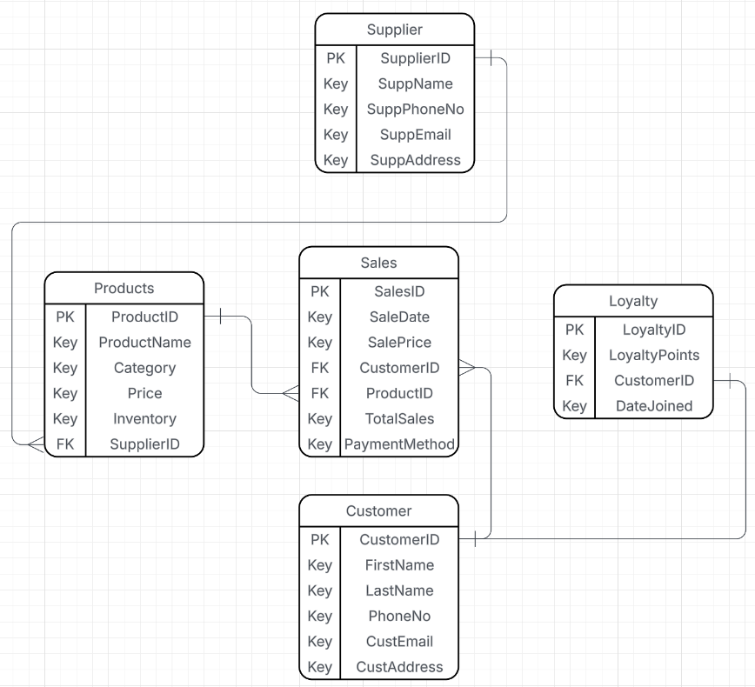  Figure 1: Corner Shop Database Schema  Implementing the Database  The next step is creating the database and tables using SQL.  Create the database:  CREATE DATABASE CornerShop;  Create the Products table:  CREATE TABLE Products (  ProductID INT PRIMARY KEY,  ProductName VARCHAR(100),  Category VARCHAR(50),  Price DECIMAL(10,2),  Inventory INT,  SupplierID INT,  FOREIGN KEY (SupplierID) REFERENCES Suppliers(SupplierID)  );  Insert initial data into the Products table:  INSERT INTO Products (ProductID, ProductName, Category, Price, Inventory, SupplierID)  VALUES  (101, 'Apple Juice', 'Beverages', 2.49, 120, 1),  (102, 'Wireless Mouse', 'Electronics', 15.99, 60, 2),  (103, 'Vacuum Cleaner', 'Home Appliances', 89.99, 25, 3);  Maintaining the Database  Maintaining the database is essential to prevent errors and data loss. Recommended measures include:  - Regular stock updates, such as automatic reductions after each sale.  - Staff training, ensuring accurate data entry to avoid duplicates or incorrect records.  - Regular audits, to verify that stock levels in the database match the physical inventory.  Backups and security are critical:  - Perform daily automated backups, stored securely on cloud storage or an external server.  - Set access controls, so only authorized staff can modify data.  - Use password protection and encryption to safeguard customer information in compliance with data protection laws.  By following these steps, the small retail shop can maintain a functional, secure, and well-organized database system that supports everyday operations and customer service.
  Relationship | Type | Explanation
  CustomerLoyalty | 1:1 | Each customer has one loyalty card record
  Customersales | 1:Many | A customer can make multiple purchases
  EmployeeSales | 1:Many | An employee can process many sales
  ProductSales | 1:Many | A product can appear in many sales
  SuppliersProducts | 1:Many | Each provide can provide many products

Day 4: Task 2: SQL Practical

In your groups, work together to answer the below questions. It may be of benefit if one of you shares your screen with the group and as a team answer / take screen shots from there.

Setting up the database:

- Download world_db(1)
- Follow each step to create your database

For each question I would like to see both the syntax used and the output.

- Count Cities in USA: Scenario: You've been tasked with conducting a demographic analysis of cities in the United States. Your first step is to determine the total number of cities within the country to provide a baseline for further analysis.

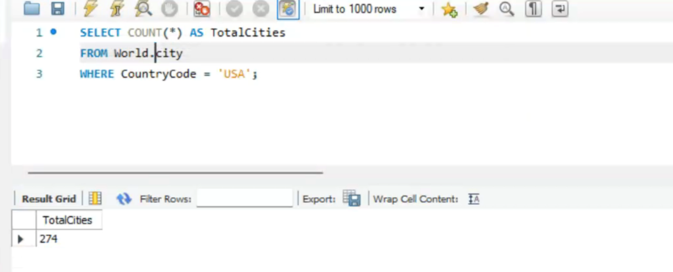

- Country with Highest Life Expectancy: Scenario: As part of a global health initiative, you've been assigned to identify the country with the highest life expectancy. This information will be crucial for prioritising healthcare resources and interventions.

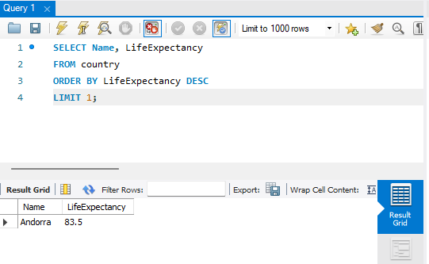

- "New Year Promotion: Featuring Cities with 'New : Scenario: In anticipation of the upcoming New Year, your travel agency is gearing up for a special promotion featuring cities with names including the word 'New'. You're tasked with swiftly compiling a list of all cities from around the world. This curated selection will be essential in creating promotional materials and enticing travellers with exciting destinations to kick off the New Year in style.

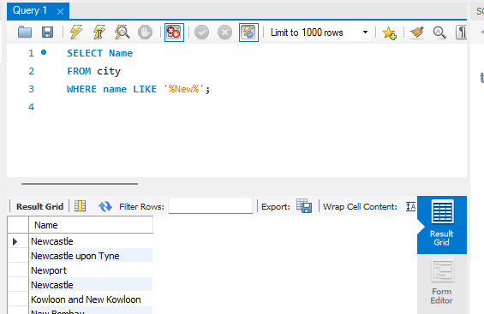

- Display Columns with Limit (First 10 Rows): Scenario: You're tasked with providing a brief overview of the most populous cities in the world. To keep the report concise, you're instructed to list only the first 10 cities by population from the database.
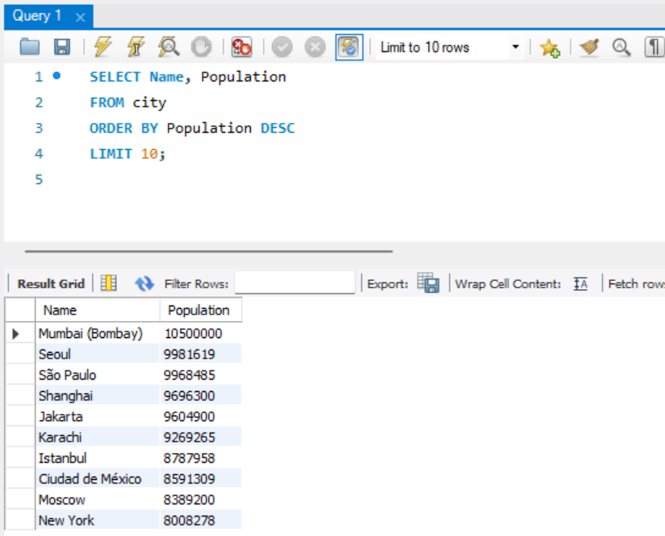

- Cities with Population Larger than 2,000,000: Scenario: A real estate developer is interested in cities with substantial population sizes for potential investment opportunities. You're tasked with identifying cities from the database with populations exceeding 2 million to focus their research efforts.
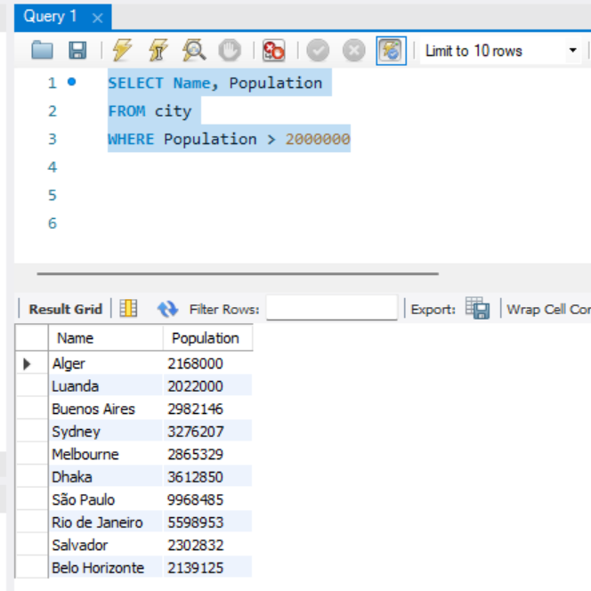

- Cities Beginning with 'Be' Prefix: Scenario: A travel blogger is planning a series of articles featuring cities with unique names. You're tasked with compiling a list of cities from the database that start with the prefix 'Be' to assist in the blogger's content creation process.
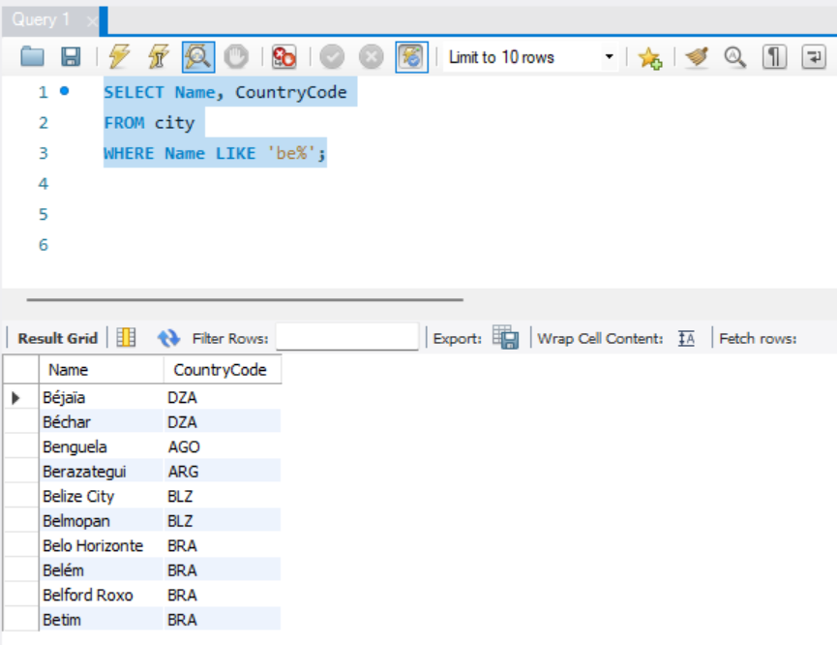

- Cities with Population Between 500,000-1,000,000: Scenario: An urban planning committee needs to identify mid-sized cities suitable for infrastructure development projects. You're tasked with identifying cities with populations ranging between 500,000 and 1 million to inform their decision-making process.
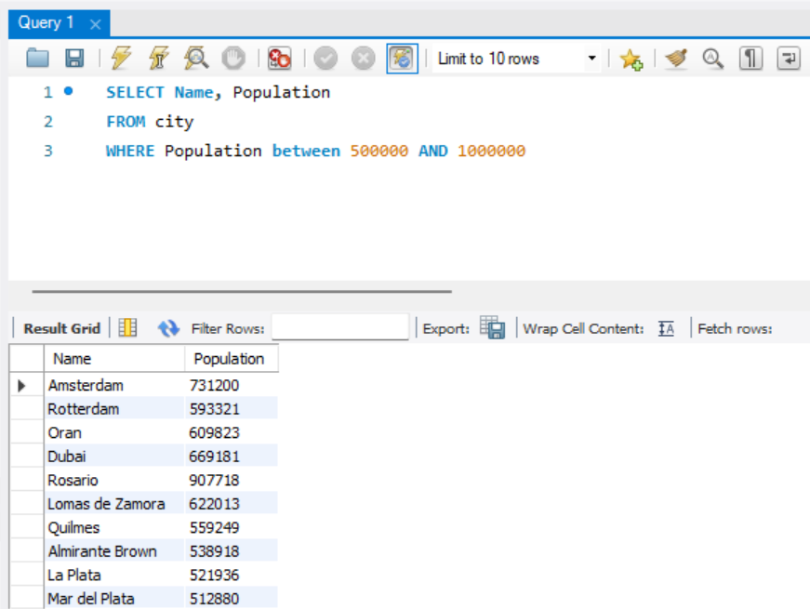

- Display Cities Sorted by Name in Ascending Order: Scenario: A geography teacher is preparing a lesson on alphabetical order using city names. You're tasked with providing a sorted list of cities from the database in ascending order by name to support the lesson plan.
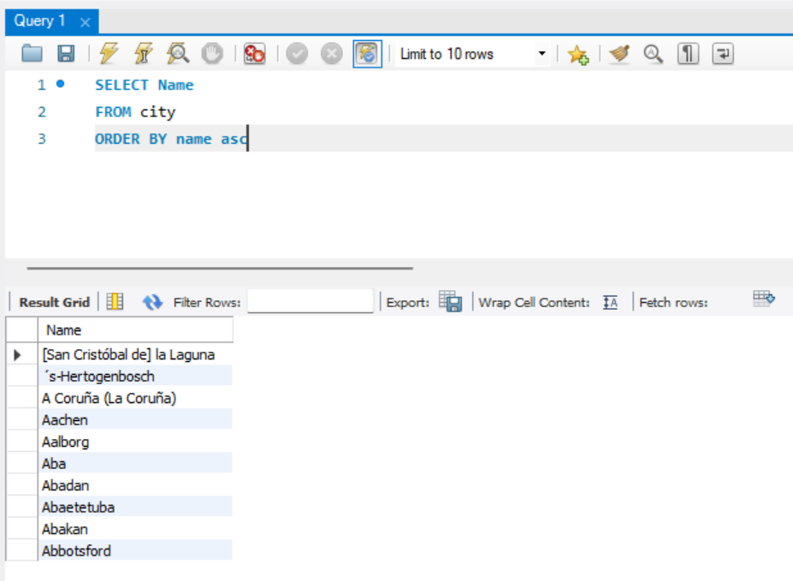

- Most Populated City: Scenario: A real estate investment firm is interested in cities with significant population densities for potential development projects. You're tasked with identifying the most populated city from the database to guide their investment decisions and strategic planning.

- City Name Frequency Analysis: Supporting Geography Education Scenario: In a geography class, students are learning about the distribution of city names around the world. The teacher, in preparation for a lesson on city name frequencies, wants to provide students with a list of unique city names sorted alphabetically, along with their respective counts of occurrences in the database. You're tasked with this sorted list to support the geography teacher.

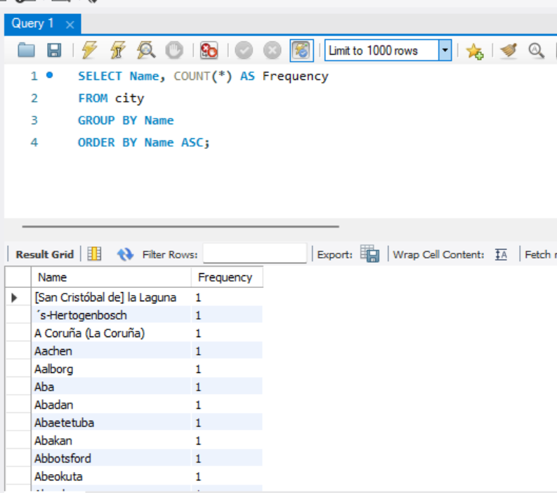

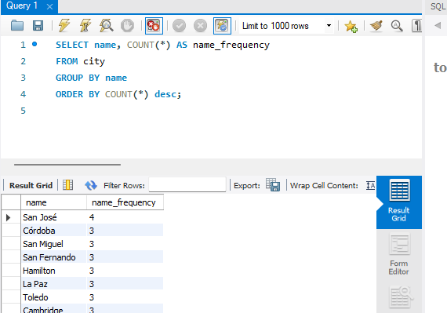

- City with the Lowest Population: Scenario: A census bureau is conducting an analysis of urban population distribution. You're tasked with identifying the city with the lowest population from the database to provide a comprehensive overview of demographic trends.

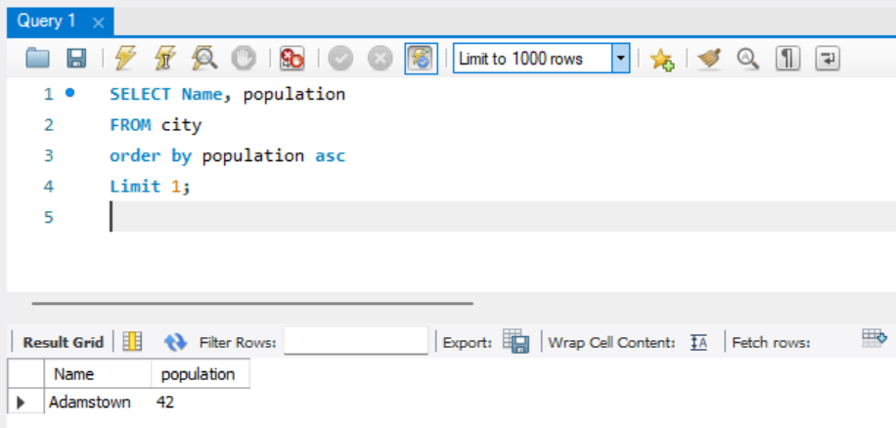

- Country with Largest Population: Scenario: A global economic research institute requires data on countries with the largest populations for a comprehensive analysis. You're tasked with identifying the country with the highest population from the database to provide valuable insights into demographic trends.
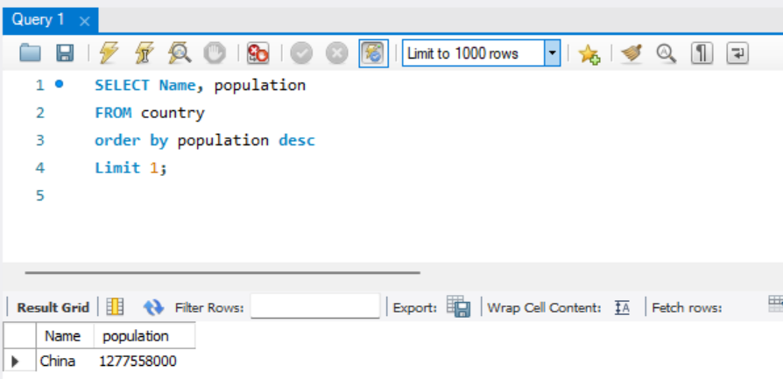

- Capital of Spain: Scenario: A travel agency is organising tours across Europe and needs accurate information on capital cities. You're tasked with identifying the capital of Spain from the database to ensure itinerary accuracy and provide travellers with essential destination information.
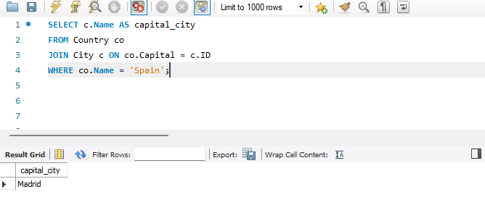

- Country with Shortest Life Expectancy: Scenario: A healthcare foundation is conducting research on global health indicators. You're tasked with identifying the country with the highest life expectancy from the database to inform their efforts in improving healthcare systems and policies.

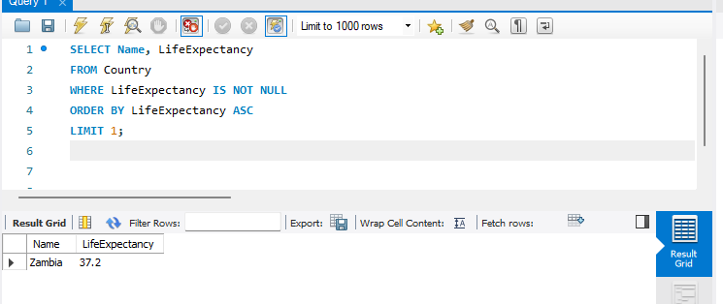

- Cities in Europe: Scenario: A European cultural exchange program is seeking to connect students with cities across the continent. You're tasked with compiling a list of cities located in Europe from the database to facilitate program planning and student engagement.

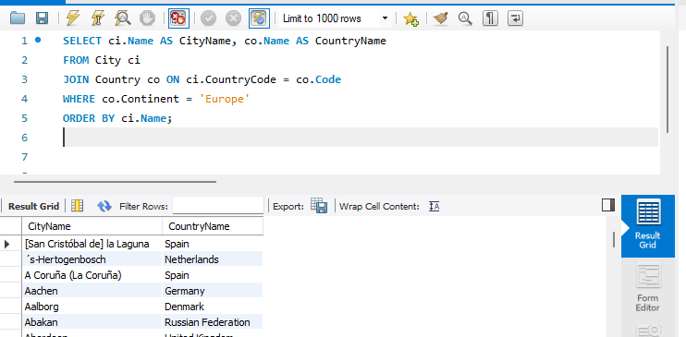

- Average Population by Country: Scenario: A demographic research team is conducting a comparative analysis of population distributions across countries. You're tasked with calculating the average population for each country from the database to provide valuable insights into global population trends.

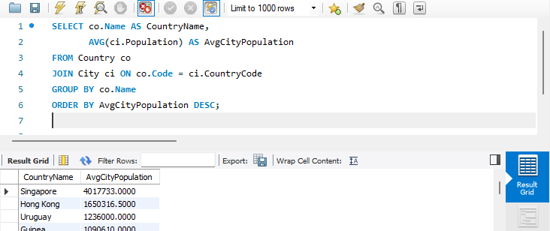

- Capital Cities Population Comparison: Scenario: A statistical analysis firm is examining population distributions between capital cities worldwide. You're tasked with comparing the populations of capital cities from different countries to identify trends and patterns in urban demographics.

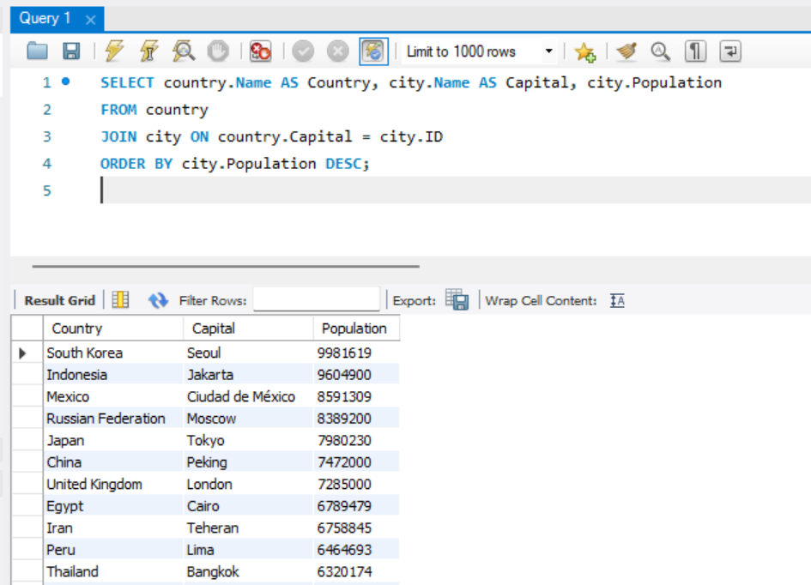

- Countries with Low Population Density: Scenario: An agricultural research institute is studying countries with low population densities for potential agricultural development projects. You're tasked with identifying countries with sparse populations from the database to support the institute's research efforts.

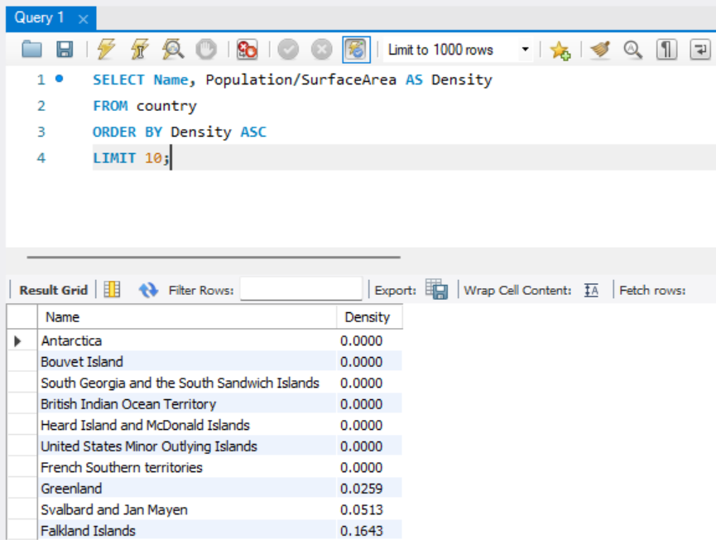

- Cities with High GDP per Capita: Scenario: An economic consulting firm is analysing cities with high GDP per capita for investment opportunities. You're tasked with identifying cities with above-average GDP per capita from the database to assist the firm in identifying potential investment destinations.

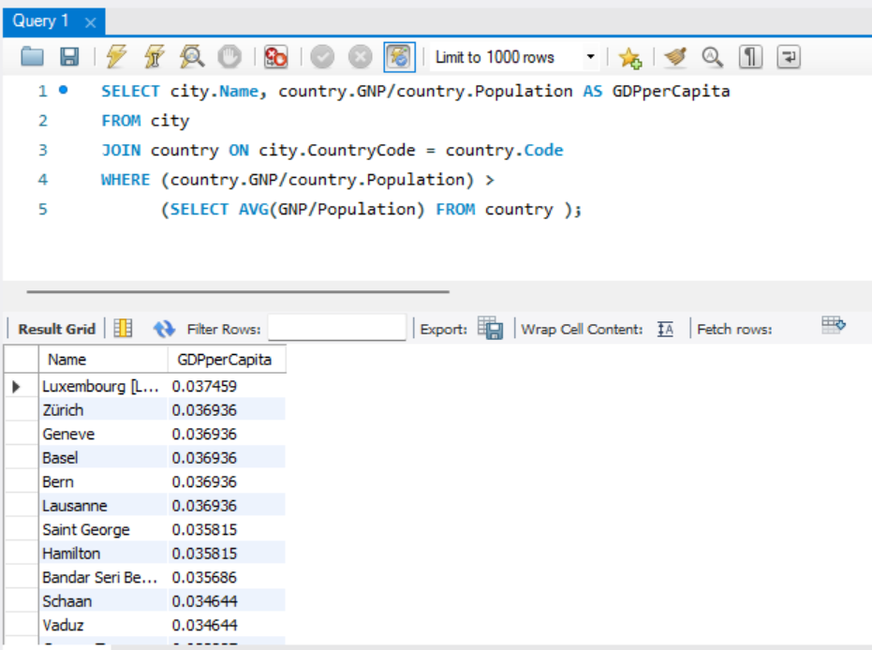

- Display Columns with Limit (Rows 31-40): Scenario: A market research firm requires detailed information on cities beyond the top rankings for a comprehensive analysis. You're tasked with providing data on cities ranked between 31st and 40th by population to ensure a thorough understanding of urban demographics.

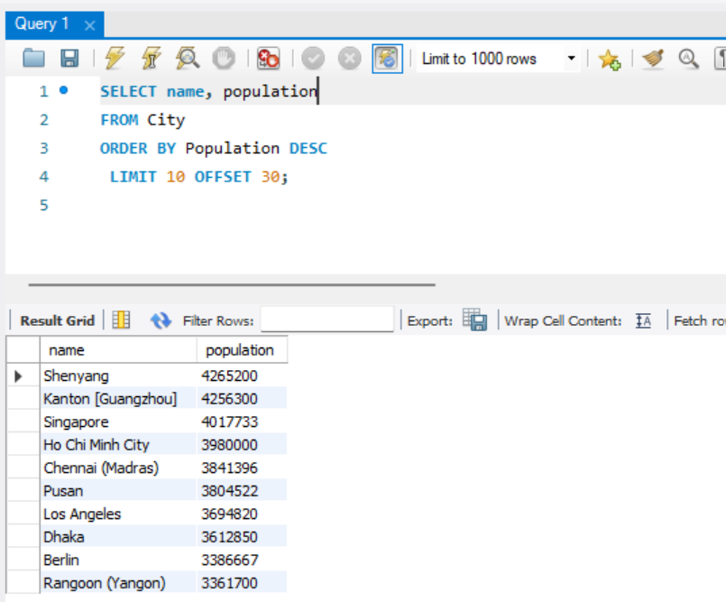

Course Notes

It is recommended to take notes from the course, use the space below to do so, or use the revision guide shared with the class:

Additional Information

We have included a range of additional links to further resources and information that you may find useful, these can be found within your revision guide.

END OF WORKBOOK

Please check through your work thoroughly before submitting and update the table of contents if required.

Please send your completed work booklet to your trainer.

